LLM and AI Agent Applications with LangChain and LangGraph

Part 25: AI Agents architectures(and How to Organize Them)
In this article I’ll demonstrate different types of AI agents. This topic is useful because it helps you understand how many ways “intelligent agents” can behave and be organized — from simple reactive systems all the way to complex structures of multiple models working together.
We’ll start with the classic view: types of agents based on their behavior and learning capability. Then we’ll move to a second view that is especially practical when building real systems in LangGraph: how agents can be organized into structures and nodes, especially in multi-agent setups.

Agent types by behavior and learning
We can distinguish five main types of agents that form a kind of evolutionary ladder — from the simplest to the most advanced.

1) Simple reactive agent
This is the most basic type: it reacts only to the current stimulus using “if… then…” rules.
It has no memory, it doesn’t plan — it simply responds to what it sees right now.
The classic example is a thermostat: if the temperature drops below a threshold, it turns the heating on.

2) Reactive agent with a world model
This kind of agent remembers what already happened and builds a simple representation of the environment.
For example: a robot that knows there’s an obstacle around the corner because it saw it a moment ago, so it doesn’t need to approach again to “discover” it. Or a chatbot that has access to conversation history.

3) Goal-based agent
Here planning enters the picture. The agent knows what it wants to achieve and chooses actions that help it reach the goal.
For example: a robot that must reach a specific room — it doesn’t react to everything on the way, it plans a route. Or a research-style application that gathers information and then tries to solve a given research problem.

4) Utility-based agent
This agent doesn’t just aim for a goal — it analyzes how beneficial different options are.
Example: an autonomous car that chooses a route not only based on distance, but also safety and cost-efficiency.

5) Learning agent
This is the most advanced type. It can analyze the consequences of its actions and improve over time.
It has its own learning mechanism, some form of critic, and sometimes even a generator of new ideas — so with each iteration its behavior becomes better.
You can see the pattern: each next type adds another layer of intelligence:
reaction → memory → planning → evaluation → learning
When designing agent applications in LangGraph, it’s worth thinking about how advanced an approach your system actually needs.

Agent types by collaboration structure (multi-agent architecture)
Now let’s move to a second classification, which becomes especially important in practice when we build multi-agent systems.
This view focuses on how agents cooperate inside a larger structure.

1) Sequential Agent
The simplest organization: actions happen one after another, step by step.
One agent passes its output to the next stage:
agent #1 analyzes the data, agent #2 generates an answer, agent #3 evaluates it.
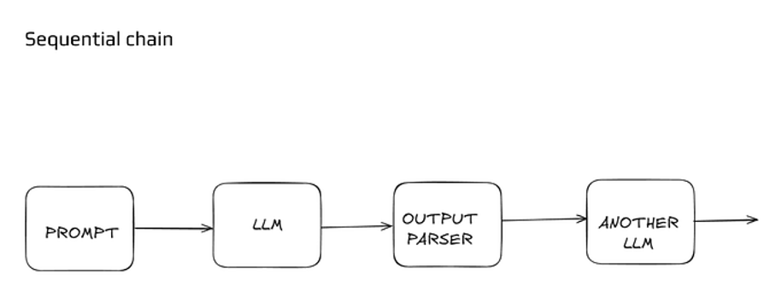
This linear sequence works well when the process is well-defined and predictable.

2) Router
A “switchboard” or dispatcher that doesn’t manage agents directly, but routes tasks to the most suitable agent.
The router analyzes what kind of task arrived and forwards it to the most competent specialist — like a support center dispatcher deciding which expert should take the call.
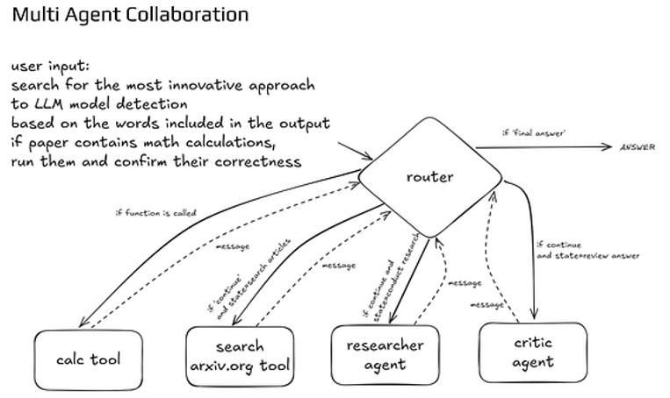
This makes the system flexible and able to adapt dynamically.

3) Supervisor
One agent supervising multiple others.
This agent plays the role of a manager: it assigns tasks, monitors progress, gathers results, and decides what happens next.
Each worker agent can be specialized — one does retrieval, another analysis, another writing/editing.
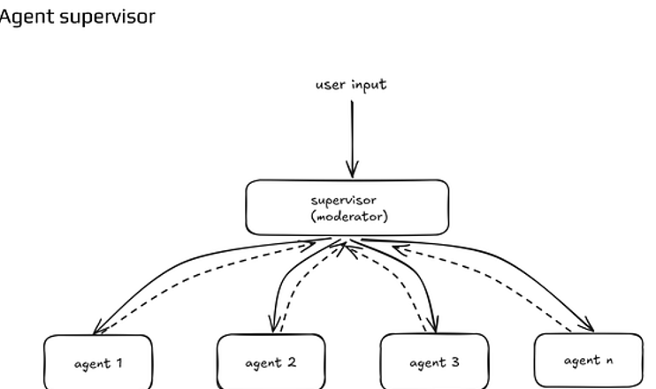
This approach gives you control over the whole process while still benefiting from specialization.

4) Hierarchical Agent System
A scalable supervisor-style architecture with multiple levels of supervision.
A top-level agent coordinates several supervisors, and each supervisor manages its own team.
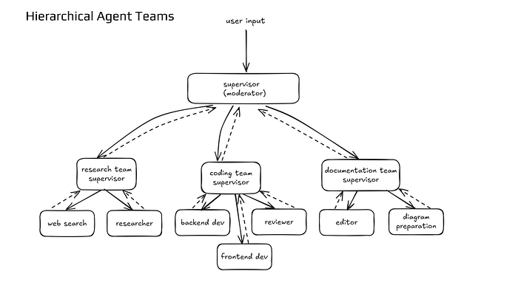
This becomes a more “corporate” agent architecture, where different layers make decisions at different scopes — strategic, tactical, operational.
This approach works especially well in large AI systems where you need to manage multi-stage processes with many specialized sub-tasks.
Now let’s move to the code and see how a few basic multi-agent architectures can be implemented in practice.

Install libraries, import dependencies and load configuration
%pip install -U langgraph langchain langchain-openai
import operator
from typing import Annotated, List, TypedDict, Literal
from langchain_openai import ChatOpenAI
from langgraph.graph import StateGraph, START, END
from dotenv import load_dotenv
load_dotenv()

Sequential Agent
Sequential Agent performs internal reasoning in several steps (so-called scratchpad) but does not use tools. It is used where pure analysis and deduction are sufficient.
llm = ChatOpenAI(model="gpt-4o-mini", temperature=0)
class State(TypedDict):
question: str
steps: Annotated[List[str], operator.add]
answer: str
def plan_node(state: State) -> dict:
sys = (
"You are a careful planner. Break the user's question into 2-4 concise steps. "
"Do not solve. Return only a numbered list of steps; no extra text."
)
messages = [("system", sys), ("user", state["question"])]
resp = llm.invoke(messages)
raw = resp.content
steps = []
for line in str(raw).splitlines():
line = line.strip()
if not line:
continue
line = line.lstrip("-• ").split(". ", 1)[-1] if ". " in line[:4] else line.lstrip("-• ")
steps.append(line)
return {"steps": steps}
def solve_node(state: State) -> dict:
"""Use the planned steps to derive the final answer only."""
sys = (
"Use the provided steps to solve the problem. "
"Return only the final answer, no reasoning."
)
messages = [
("system", sys),
("user", f"Question: {state['question']}\\\\nSteps: {state['steps']}"),
]
resp = llm.invoke(messages)
return {"answer": str(resp.content).strip()}
# Wire up the graph
graph = StateGraph(State)
graph.add_node("plan", plan_node)
graph.add_node("solve", solve_node)
graph.add_edge(START, "plan")
graph.add_edge("plan", "solve")
graph.add_edge("solve", END)
cot_graph = graph.compile()
run agent:
state = {
"question": "If a book has 350 pages and I read 14 pages per day, how many days to finish?",
"steps": [],
"answer": ""
}
out = cot_graph.invoke(state)
print("Final answer:", out["answer"])
output:
Final answer: 25 days

Router Agent
Custom Agent provides complete flexibility. You define the logic, routing, and nodes yourself.
class CustomState(TypedDict):
input: str
task: Literal["math", "capitalize", "count"]
result: str
def route(state: CustomState) -> str:
"""Deterministic router based on a simple protocol in the input."""
text = state["input"].strip().lower()
if text.startswith("math:"):
return "math"
if text.startswith("capitalize:"):
return "capitalize"
if text.startswith("count:"):
return "count"
return "count"
def do_math(state: CustomState) -> dict:
expr = state["input"].split(":", 1)[-1].strip()
allowed = set("0123456789+-*/(). ")
if any(c not in allowed for c in expr):
return {"result": "Error: unsupported characters in math expression."}
try:
res = eval(expr, {"__builtins__": {}})
except Exception as e:
res = f"Error: {e}"
return {"result": str(res)}
def do_capitalize(state: CustomState) -> dict:
text = state["input"].split(":", 1)[-1].strip()
return {"result": text.upper()}
def do_count(state: CustomState) -> dict:
text = state["input"].split(":", 1)[-1].strip()
tokens = [t for t in text.split() if t]
return {"result": f"words={len(tokens)} chars={len(text)}"}
graph = StateGraph(CustomState)
graph.add_node("math", do_math)
graph.add_node("capitalize", do_capitalize)
graph.add_node("count", do_count)
graph.add_conditional_edges(
START,
route,
{
"math": "math",
"capitalize": "capitalize",
"count": "count",
},
)
graph.add_edge("math", END)
graph.add_edge("capitalize", END)
graph.add_edge("count", END)
custom_agent = graph.compile(debug=True)
run agent:
for user_input in [
"math: (12 + 8) * 3",
"capitalize: langgraph is great!",
"count: How many words are here?",
]:
out = custom_agent.invoke({"input": user_input, "task": "count", "result": ""})
print(f"Input: {user_input}\nResult: {out['result']}\n---")
output:
[values] {'input': 'math: (12 + 8) * 3', 'task': 'count', 'result': ''}
[updates] {'math': {'result': '60'}}
[values] {'input': 'math: (12 + 8) * 3', 'task': 'count', 'result': '60'}
Input: math: (12 + 8) * 3
Result: 60
---
[values] {'input': 'capitalize: langgraph is great!', 'task': 'count', 'result': ''}
[updates] {'capitalize': {'result': 'LANGGRAPH IS GREAT!'}}
[values] {'input': 'capitalize: langgraph is great!', 'task': 'count', 'result': 'LANGGRAPH IS GREAT!'}
Input: capitalize: langgraph is great!
Result: LANGGRAPH IS GREAT!
---
[values] {'input': 'count: How many words are here?', 'task': 'count', 'result': ''}
[updates] {'count': {'result': 'words=5 chars=24'}}
[values] {'input': 'count: How many words are here?', 'task': 'count', 'result': 'words=5 chars=24'}
Input: count: How many words are here?
Result: words=5 chars=24
---

Supervisor agent
class SupervisorState(TypedDict):
"""State for supervisor pattern with multiple agents."""
topic: str
messages: Annotated[List[str], operator.add]
next_agent: str
final_answer: str
def researcher_agent(state: SupervisorState) -> dict:
"""Researcher agent gathers information about the topic."""
sys = (
"You are a researcher. Your job is to gather key facts and information "
"about the given topic. Provide 2-3 key points. Be concise."
)
messages_for_llm = [
("system", sys),
("user", f"Research this topic: {state['topic']}")
]
resp = llm.invoke(messages_for_llm)
research_msg = f"RESEARCHER: {resp.content}"
return {"messages": [research_msg]}
def expert_agent(state: SupervisorState) -> dict:
"""Expert agent analyzes and provides insights based on research."""
sys = (
"You are an expert analyst. Review the research provided and give "
"your expert analysis and conclusions. Be specific and insightful."
)
# Get context from previous messages
context = "\n".join(state["messages"])
messages_for_llm = [
("system", sys),
("user", f"Topic: {state['topic']}\n\nPrevious research:\n{context}\n\nProvide your expert analysis.")
]
resp = llm.invoke(messages_for_llm)
expert_msg = f"EXPERT: {resp.content}"
return {"messages": [expert_msg]}
def supervisor_agent(state: SupervisorState) -> dict:
"""Supervisor decides which agent should act next or if discussion should end."""
sys = (
"You are a supervisor managing a research discussion between a RESEARCHER and an EXPERT. "
"Based on the conversation so far, decide what should happen next:\n"
"- Return 'researcher' if we need initial research or more information\n"
"- Return 'expert' if research is done and we need expert analysis\n"
"- Return 'end' if both research and expert analysis are complete\n\n"
"Respond with ONLY one word: researcher, expert, or end"
)
context = "\n".join(state["messages"]) if state["messages"] else "No discussion yet"
messages_for_llm = [
("system", sys),
("user", f"Topic: {state['topic']}\n\nConversation:\n{context}\n\nWhat's next?")
]
resp = llm.invoke(messages_for_llm)
next_step = resp.content.strip().lower()
# Ensure valid response
if next_step not in ["researcher", "expert", "end"]:
next_step = "end"
return {"next_agent": next_step}
def finalize_answer(state: SupervisorState) -> dict:
"""Compile final answer from the discussion."""
sys = (
"Summarize the research discussion into a clear, concise final answer. "
"Include key findings and expert insights."
)
context = "\n".join(state["messages"])
messages_for_llm = [
("system", sys),
("user", f"Topic: {state['topic']}\n\nDiscussion:\n{context}\n\nProvide final summary:")
]
resp = llm.invoke(messages_for_llm)
return {"final_answer": resp.content}
def route_supervisor(state: SupervisorState) -> str:
"""Route based on supervisor's decision."""
next_agent = state.get("next_agent", "researcher")
if next_agent == "end":
return "finalize"
return next_agent
supervisor_graph = StateGraph(SupervisorState)
supervisor_graph.add_node("supervisor", supervisor_agent)
supervisor_graph.add_node("researcher", researcher_agent)
supervisor_graph.add_node("expert", expert_agent)
supervisor_graph.add_node("finalize", finalize_answer)
supervisor_graph.add_edge(START, "supervisor")
supervisor_graph.add_conditional_edges(
"supervisor",
route_supervisor,
{
"researcher": "researcher",
"expert": "expert",
"finalize": "finalize"
}
)
supervisor_graph.add_edge("researcher", "supervisor")
supervisor_graph.add_edge("expert", "supervisor")
supervisor_graph.add_edge("finalize", END)
supervisor_agent_graph = supervisor_graph.compile(debug=True)
run agent:
topic = "What are the main benefits of using LangGraph for building AI agents?"
initial_state = {
"topic": topic,
"messages": [],
"next_agent": "",
"final_answer": ""
}
result = supervisor_agent_graph.invoke(initial_state)
print(f"TOPIC: {topic}\n")
print("=" * 80)
print("\nDISCUSSION:")
print("-" * 80)
for msg in result["messages"]:
print(f"\n{msg}\n")
print("=" * 80)
print(f"\nFINAL ANSWER:\n{result['final_answer']}")
output:
[values] {'topic': 'What are the main benefits of using LangGraph for building AI agents?', 'messages': [], 'next_agent': '', 'final_answer': ''}
[updates] {'supervisor': {'next_agent': 'researcher'}}
[values] {'topic': 'What are the main benefits of using LangGraph for building AI agents?', 'messages': [], 'next_agent': 'researcher', 'final_answer': ''}
[updates] {'researcher': {'messages': ['RESEARCHER: 1. **Modular Design**: LangGraph offers a modular architecture that allows developers to easily integrate various components and functionalities, facilitating the rapid development and customization of AI agents.\n\n2. **Enhanced Natural Language Processing**: It leverages advanced natural language processing capabilities, enabling AI agents to understand and generate human-like responses, improving user interaction and engagement.\n\n3. **Scalability and Flexibility**: LangGraph is designed to be scalable, allowing developers to build AI agents that can handle varying workloads and adapt to different use cases, making it suitable for both small projects and large-scale applications.']}}
[values] {'topic': 'What are the main benefits of using LangGraph for building AI agents?', 'messages': ['RESEARCHER: 1. **Modular Design**: LangGraph offers a modular architecture that allows developers to easily integrate various components and functionalities, facilitating the rapid development and customization of AI agents.\n\n2. **Enhanced Natural Language Processing**: It leverages advanced natural language processing capabilities, enabling AI agents to understand and generate human-like responses, improving user interaction and engagement.\n\n3. **Scalability and Flexibility**: LangGraph is designed to be scalable, allowing developers to build AI agents that can handle varying workloads and adapt to different use cases, making it suitable for both small projects and large-scale applications.'], 'next_agent': 'researcher', 'final_answer': ''}
[updates] {'supervisor': {'next_agent': 'expert'}}
[values] {'topic': 'What are the main benefits of using LangGraph for building AI agents?', 'messages': ['RESEARCHER: 1. **Modular Design**: LangGraph offers a modular architecture that allows developers to easily integrate various components and functionalities, facilitating the rapid development and customization of AI agents.\n\n2. **Enhanced Natural Language Processing**: It leverages advanced natural language processing capabilities, enabling AI agents to understand and generate human-like responses, improving user interaction and engagement.\n\n3. **Scalability and Flexibility**: LangGraph is designed to be scalable, allowing developers to build AI agents that can handle varying workloads and adapt to different use cases, making it suitable for both small projects and large-scale applications.'], 'next_agent': 'expert', 'final_answer': ''}
[updates] {'expert': {'messages': ['EXPERT: The research highlights several key benefits of using LangGraph for building AI agents, each of which plays a crucial role in the development and deployment of effective AI solutions. Here’s a detailed analysis of the points raised:\n\n1. **Modular Design**:\n - **Analysis**: The modular architecture of LangGraph is a significant advantage for developers. It allows for the separation of concerns, meaning that different functionalities can be developed, tested, and maintained independently. This modularity not only accelerates the development process but also enhances the ability to customize AI agents to meet specific needs. Developers can easily swap out components or add new features without overhauling the entire system, which is particularly beneficial in agile development environments where requirements may evolve rapidly.\n - **Conclusion**: The modular design fosters innovation and experimentation, enabling teams to iterate quickly and respond to user feedback effectively. This flexibility can lead to more robust and user-centric AI solutions.\n\n2. **Enhanced Natural Language Processing**:\n - **Analysis**: The emphasis on advanced natural language processing (NLP) capabilities is critical in today’s AI landscape, where user interaction is often mediated through conversational interfaces. LangGraph’s ability to understand and generate human-like responses can significantly enhance user experience, making interactions more intuitive and engaging. This is particularly important in applications such as customer service, virtual assistants, and educational tools, where effective communication is paramount.\n - **Conclusion**: By improving the quality of interactions, LangGraph can help organizations build stronger relationships with users, leading to higher satisfaction and retention rates. The enhanced NLP capabilities position LangGraph as a competitive choice for developers focused on creating conversational AI.\n\n3. **Scalability and Flexibility**:\n - **Analysis**: Scalability is a critical factor for any technology that aims to support a wide range of applications, from small-scale projects to enterprise-level solutions. LangGraph’s design allows developers to scale their AI agents seamlessly, accommodating increased workloads without compromising performance. This flexibility is essential for businesses that anticipate growth or fluctuating demand, as it ensures that their AI solutions can evolve alongside their needs.\n - **Conclusion**: The ability to scale effectively means that organizations can invest in LangGraph with confidence, knowing that their AI agents can grow and adapt over time. This adaptability is a key differentiator in a market where businesses are increasingly looking for long-term, sustainable technology solutions.\n\n**Overall Insights**:\nLangGraph presents a compelling option for developers looking to build AI agents due to its modular design, advanced NLP capabilities, and scalability. These features not only streamline the development process but also enhance the end-user experience, making it easier for organizations to deploy effective AI solutions that can adapt to changing needs. As AI continues to evolve, tools like LangGraph that prioritize flexibility and user engagement will likely become increasingly valuable in the tech landscape. \n\nIn conclusion, LangGraph stands out as a robust framework for AI agent development, offering significant advantages that can lead to more efficient development cycles, improved user interactions, and scalable solutions that meet diverse business needs.']}}
[values] {'topic': 'What are the main benefits of using LangGraph for building AI agents?', 'messages': ['RESEARCHER: 1. **Modular Design**: LangGraph offers a modular architecture that allows developers to easily integrate various components and functionalities, facilitating the rapid development and customization of AI agents.\n\n2. **Enhanced Natural Language Processing**: It leverages advanced natural language processing capabilities, enabling AI agents to understand and generate human-like responses, improving user interaction and engagement.\n\n3. **Scalability and Flexibility**: LangGraph is designed to be scalable, allowing developers to build AI agents that can handle varying workloads and adapt to different use cases, making it suitable for both small projects and large-scale applications.', 'EXPERT: The research highlights several key benefits of using LangGraph for building AI agents, each of which plays a crucial role in the development and deployment of effective AI solutions. Here’s a detailed analysis of the points raised:\n\n1. **Modular Design**:\n - **Analysis**: The modular architecture of LangGraph is a significant advantage for developers. It allows for the separation of concerns, meaning that different functionalities can be developed, tested, and maintained independently. This modularity not only accelerates the development process but also enhances the ability to customize AI agents to meet specific needs. Developers can easily swap out components or add new features without overhauling the entire system, which is particularly beneficial in agile development environments where requirements may evolve rapidly.\n - **Conclusion**: The modular design fosters innovation and experimentation, enabling teams to iterate quickly and respond to user feedback effectively. This flexibility can lead to more robust and user-centric AI solutions.\n\n2. **Enhanced Natural Language Processing**:\n - **Analysis**: The emphasis on advanced natural language processing (NLP) capabilities is critical in today’s AI landscape, where user interaction is often mediated through conversational interfaces. LangGraph’s ability to understand and generate human-like responses can significantly enhance user experience, making interactions more intuitive and engaging. This is particularly important in applications such as customer service, virtual assistants, and educational tools, where effective communication is paramount.\n - **Conclusion**: By improving the quality of interactions, LangGraph can help organizations build stronger relationships with users, leading to higher satisfaction and retention rates. The enhanced NLP capabilities position LangGraph as a competitive choice for developers focused on creating conversational AI.\n\n3. **Scalability and Flexibility**:\n - **Analysis**: Scalability is a critical factor for any technology that aims to support a wide range of applications, from small-scale projects to enterprise-level solutions. LangGraph’s design allows developers to scale their AI agents seamlessly, accommodating increased workloads without compromising performance. This flexibility is essential for businesses that anticipate growth or fluctuating demand, as it ensures that their AI solutions can evolve alongside their needs.\n - **Conclusion**: The ability to scale effectively means that organizations can invest in LangGraph with confidence, knowing that their AI agents can grow and adapt over time. This adaptability is a key differentiator in a market where businesses are increasingly looking for long-term, sustainable technology solutions.\n\n**Overall Insights**:\nLangGraph presents a compelling option for developers looking to build AI agents due to its modular design, advanced NLP capabilities, and scalability. These features not only streamline the development process but also enhance the end-user experience, making it easier for organizations to deploy effective AI solutions that can adapt to changing needs. As AI continues to evolve, tools like LangGraph that prioritize flexibility and user engagement will likely become increasingly valuable in the tech landscape. \n\nIn conclusion, LangGraph stands out as a robust framework for AI agent development, offering significant advantages that can lead to more efficient development cycles, improved user interactions, and scalable solutions that meet diverse business needs.'], 'next_agent': 'expert', 'final_answer': ''}
[updates] {'supervisor': {'next_agent': 'end'}}
[values] {'topic': 'What are the main benefits of using LangGraph for building AI agents?', 'messages': ['RESEARCHER: 1. **Modular Design**: LangGraph offers a modular architecture that allows developers to easily integrate various components and functionalities, facilitating the rapid development and customization of AI agents.\n\n2. **Enhanced Natural Language Processing**: It leverages advanced natural language processing capabilities, enabling AI agents to understand and generate human-like responses, improving user interaction and engagement.\n\n3. **Scalability and Flexibility**: LangGraph is designed to be scalable, allowing developers to build AI agents that can handle varying workloads and adapt to different use cases, making it suitable for both small projects and large-scale applications.', 'EXPERT: The research highlights several key benefits of using LangGraph for building AI agents, each of which plays a crucial role in the development and deployment of effective AI solutions. Here’s a detailed analysis of the points raised:\n\n1. **Modular Design**:\n - **Analysis**: The modular architecture of LangGraph is a significant advantage for developers. It allows for the separation of concerns, meaning that different functionalities can be developed, tested, and maintained independently. This modularity not only accelerates the development process but also enhances the ability to customize AI agents to meet specific needs. Developers can easily swap out components or add new features without overhauling the entire system, which is particularly beneficial in agile development environments where requirements may evolve rapidly.\n - **Conclusion**: The modular design fosters innovation and experimentation, enabling teams to iterate quickly and respond to user feedback effectively. This flexibility can lead to more robust and user-centric AI solutions.\n\n2. **Enhanced Natural Language Processing**:\n - **Analysis**: The emphasis on advanced natural language processing (NLP) capabilities is critical in today’s AI landscape, where user interaction is often mediated through conversational interfaces. LangGraph’s ability to understand and generate human-like responses can significantly enhance user experience, making interactions more intuitive and engaging. This is particularly important in applications such as customer service, virtual assistants, and educational tools, where effective communication is paramount.\n - **Conclusion**: By improving the quality of interactions, LangGraph can help organizations build stronger relationships with users, leading to higher satisfaction and retention rates. The enhanced NLP capabilities position LangGraph as a competitive choice for developers focused on creating conversational AI.\n\n3. **Scalability and Flexibility**:\n - **Analysis**: Scalability is a critical factor for any technology that aims to support a wide range of applications, from small-scale projects to enterprise-level solutions. LangGraph’s design allows developers to scale their AI agents seamlessly, accommodating increased workloads without compromising performance. This flexibility is essential for businesses that anticipate growth or fluctuating demand, as it ensures that their AI solutions can evolve alongside their needs.\n - **Conclusion**: The ability to scale effectively means that organizations can invest in LangGraph with confidence, knowing that their AI agents can grow and adapt over time. This adaptability is a key differentiator in a market where businesses are increasingly looking for long-term, sustainable technology solutions.\n\n**Overall Insights**:\nLangGraph presents a compelling option for developers looking to build AI agents due to its modular design, advanced NLP capabilities, and scalability. These features not only streamline the development process but also enhance the end-user experience, making it easier for organizations to deploy effective AI solutions that can adapt to changing needs. As AI continues to evolve, tools like LangGraph that prioritize flexibility and user engagement will likely become increasingly valuable in the tech landscape. \n\nIn conclusion, LangGraph stands out as a robust framework for AI agent development, offering significant advantages that can lead to more efficient development cycles, improved user interactions, and scalable solutions that meet diverse business needs.'], 'next_agent': 'end', 'final_answer': ''}
[updates] {'finalize': {'final_answer': "LangGraph offers several key benefits for building AI agents, making it a compelling choice for developers. \n\n1. **Modular Design**: Its modular architecture allows for easy integration and customization of components, facilitating rapid development and enabling teams to iterate quickly in response to user feedback.\n\n2. **Enhanced Natural Language Processing**: LangGraph's advanced NLP capabilities improve user interactions by enabling AI agents to understand and generate human-like responses, which is crucial for applications like customer service and virtual assistants.\n\n3. **Scalability and Flexibility**: The framework is designed to scale seamlessly, accommodating varying workloads and adapting to different use cases, which is essential for businesses anticipating growth or fluctuating demands.\n\nOverall, LangGraph streamlines the development process, enhances user engagement, and provides scalable solutions, positioning it as a valuable tool in the evolving AI landscape."}}
[values] {'topic': 'What are the main benefits of using LangGraph for building AI agents?', 'messages': ['RESEARCHER: 1. **Modular Design**: LangGraph offers a modular architecture that allows developers to easily integrate various components and functionalities, facilitating the rapid development and customization of AI agents.\n\n2. **Enhanced Natural Language Processing**: It leverages advanced natural language processing capabilities, enabling AI agents to understand and generate human-like responses, improving user interaction and engagement.\n\n3. **Scalability and Flexibility**: LangGraph is designed to be scalable, allowing developers to build AI agents that can handle varying workloads and adapt to different use cases, making it suitable for both small projects and large-scale applications.', 'EXPERT: The research highlights several key benefits of using LangGraph for building AI agents, each of which plays a crucial role in the development and deployment of effective AI solutions. Here’s a detailed analysis of the points raised:\n\n1. **Modular Design**:\n - **Analysis**: The modular architecture of LangGraph is a significant advantage for developers. It allows for the separation of concerns, meaning that different functionalities can be developed, tested, and maintained independently. This modularity not only accelerates the development process but also enhances the ability to customize AI agents to meet specific needs. Developers can easily swap out components or add new features without overhauling the entire system, which is particularly beneficial in agile development environments where requirements may evolve rapidly.\n - **Conclusion**: The modular design fosters innovation and experimentation, enabling teams to iterate quickly and respond to user feedback effectively. This flexibility can lead to more robust and user-centric AI solutions.\n\n2. **Enhanced Natural Language Processing**:\n - **Analysis**: The emphasis on advanced natural language processing (NLP) capabilities is critical in today’s AI landscape, where user interaction is often mediated through conversational interfaces. LangGraph’s ability to understand and generate human-like responses can significantly enhance user experience, making interactions more intuitive and engaging. This is particularly important in applications such as customer service, virtual assistants, and educational tools, where effective communication is paramount.\n - **Conclusion**: By improving the quality of interactions, LangGraph can help organizations build stronger relationships with users, leading to higher satisfaction and retention rates. The enhanced NLP capabilities position LangGraph as a competitive choice for developers focused on creating conversational AI.\n\n3. **Scalability and Flexibility**:\n - **Analysis**: Scalability is a critical factor for any technology that aims to support a wide range of applications, from small-scale projects to enterprise-level solutions. LangGraph’s design allows developers to scale their AI agents seamlessly, accommodating increased workloads without compromising performance. This flexibility is essential for businesses that anticipate growth or fluctuating demand, as it ensures that their AI solutions can evolve alongside their needs.\n - **Conclusion**: The ability to scale effectively means that organizations can invest in LangGraph with confidence, knowing that their AI agents can grow and adapt over time. This adaptability is a key differentiator in a market where businesses are increasingly looking for long-term, sustainable technology solutions.\n\n**Overall Insights**:\nLangGraph presents a compelling option for developers looking to build AI agents due to its modular design, advanced NLP capabilities, and scalability. These features not only streamline the development process but also enhance the end-user experience, making it easier for organizations to deploy effective AI solutions that can adapt to changing needs. As AI continues to evolve, tools like LangGraph that prioritize flexibility and user engagement will likely become increasingly valuable in the tech landscape. \n\nIn conclusion, LangGraph stands out as a robust framework for AI agent development, offering significant advantages that can lead to more efficient development cycles, improved user interactions, and scalable solutions that meet diverse business needs.'], 'next_agent': 'end', 'final_answer': "LangGraph offers several key benefits for building AI agents, making it a compelling choice for developers. \n\n1. **Modular Design**: Its modular architecture allows for easy integration and customization of components, facilitating rapid development and enabling teams to iterate quickly in response to user feedback.\n\n2. **Enhanced Natural Language Processing**: LangGraph's advanced NLP capabilities improve user interactions by enabling AI agents to understand and generate human-like responses, which is crucial for applications like customer service and virtual assistants.\n\n3. **Scalability and Flexibility**: The framework is designed to scale seamlessly, accommodating varying workloads and adapting to different use cases, which is essential for businesses anticipating growth or fluctuating demands.\n\nOverall, LangGraph streamlines the development process, enhances user engagement, and provides scalable solutions, positioning it as a valuable tool in the evolving AI landscape."}
TOPIC: What are the main benefits of using LangGraph for building AI agents?
================================================================================
DISCUSSION:
--------------------------------------------------------------------------------
RESEARCHER: 1. **Modular Design**: LangGraph offers a modular architecture that allows developers to easily integrate various components and functionalities, facilitating the rapid development and customization of AI agents.
2. **Enhanced Natural Language Processing**: It leverages advanced natural language processing capabilities, enabling AI agents to understand and generate human-like responses, improving user interaction and engagement.
3. **Scalability and Flexibility**: LangGraph is designed to be scalable, allowing developers to build AI agents that can handle varying workloads and adapt to different use cases, making it suitable for both small projects and large-scale applications.
EXPERT: The research highlights several key benefits of using LangGraph for building AI agents, each of which plays a crucial role in the development and deployment of effective AI solutions. Here’s a detailed analysis of the points raised:
1. **Modular Design**:
- **Analysis**: The modular architecture of LangGraph is a significant advantage for developers. It allows for the separation of concerns, meaning that different functionalities can be developed, tested, and maintained independently. This modularity not only accelerates the development process but also enhances the ability to customize AI agents to meet specific needs. Developers can easily swap out components or add new features without overhauling the entire system, which is particularly beneficial in agile development environments where requirements may evolve rapidly.
- **Conclusion**: The modular design fosters innovation and experimentation, enabling teams to iterate quickly and respond to user feedback effectively. This flexibility can lead to more robust and user-centric AI solutions.
2. **Enhanced Natural Language Processing**:
- **Analysis**: The emphasis on advanced natural language processing (NLP) capabilities is critical in today’s AI landscape, where user interaction is often mediated through conversational interfaces. LangGraph’s ability to understand and generate human-like responses can significantly enhance user experience, making interactions more intuitive and engaging. This is particularly important in applications such as customer service, virtual assistants, and educational tools, where effective communication is paramount.
- **Conclusion**: By improving the quality of interactions, LangGraph can help organizations build stronger relationships with users, leading to higher satisfaction and retention rates. The enhanced NLP capabilities position LangGraph as a competitive choice for developers focused on creating conversational AI.
3. **Scalability and Flexibility**:
- **Analysis**: Scalability is a critical factor for any technology that aims to support a wide range of applications, from small-scale projects to enterprise-level solutions. LangGraph’s design allows developers to scale their AI agents seamlessly, accommodating increased workloads without compromising performance. This flexibility is essential for businesses that anticipate growth or fluctuating demand, as it ensures that their AI solutions can evolve alongside their needs.
- **Conclusion**: The ability to scale effectively means that organizations can invest in LangGraph with confidence, knowing that their AI agents can grow and adapt over time. This adaptability is a key differentiator in a market where businesses are increasingly looking for long-term, sustainable technology solutions.
**Overall Insights**:
LangGraph presents a compelling option for developers looking to build AI agents due to its modular design, advanced NLP capabilities, and scalability. These features not only streamline the development process but also enhance the end-user experience, making it easier for organizations to deploy effective AI solutions that can adapt to changing needs. As AI continues to evolve, tools like LangGraph that prioritize flexibility and user engagement will likely become increasingly valuable in the tech landscape.
In conclusion, LangGraph stands out as a robust framework for AI agent development, offering significant advantages that can lead to more efficient development cycles, improved user interactions, and scalable solutions that meet diverse business needs.
================================================================================
FINAL ANSWER:
LangGraph offers several key benefits for building AI agents, making it a compelling choice for developers.
1. **Modular Design**: Its modular architecture allows for easy integration and customization of components, facilitating rapid development and enabling teams to iterate quickly in response to user feedback.
2. **Enhanced Natural Language Processing**: LangGraph's advanced NLP capabilities improve user interactions by enabling AI agents to understand and generate human-like responses, which is crucial for applications like customer service and virtual assistants.
3. **Scalability and Flexibility**: The framework is designed to scale seamlessly, accommodating varying workloads and adapting to different use cases, which is essential for businesses anticipating growth or fluctuating demands.
Overall, LangGraph streamlines the development process, enhances user engagement, and provides scalable solutions, positioning it as a valuable tool in the evolving AI landscape.

Summary
So we have two ways of looking at AI agents:
- Functional (behavior and capability): from simple reactive agents to learning agents.
- Architectural (collaboration structure): sequential, router, supervisor, hierarchical.
That’s all in this chapter dedicated to AI agent architectural patterns.
In the next chapter we will combine LangGraph agent with RAG.

